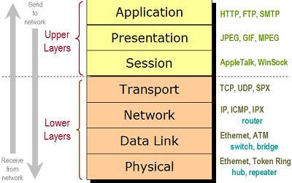

## Physical

This is the layer that transmits and receives 1’s and 0’s. On receiving it converts it into frames. This means that it is easier to read and handle the data.

## Data Link

The data link layer defines a lot of stuff about the incoming message. It will define mac and hardware addresses. How to hand it to the network layer. What methods of transport to use etc.

## Network

The router will then define the IP address and the routes for the IP. It will then send it to the required IP following the routing tables.

## Transport

The transport layer will then set up a connection between the devices.